**Risk assessment for non-crop legumes as hosts for Pea Enation Mosaic Virus and the aphid vector *Acyrothosiphon pisum*: a community ecology approach**

Robert E. Clark1,2*, Saumik Basu1, Sanford D. Eigenbrode3, Elisabeth C. Oeller1,3, David W. Crowder1

1 Department of Entomology, Washington State University, Pullman, Washington, USA

2 EcoData Technology LLC, Oxford, Connecticut, USA

3 Department of Entomology, Plant Pathology, and Nematology, University of Idaho, Moscow, Idaho, USA

* Corresponding author: [robert.e.clark@wsu.edu](mailto:robert.e.clark@wsu.edu)

Acknowledgements here

**Abstract** (300 word limit for Journal of Applied Entomology)

Viral insect-borne plant pathogens have devastating impacts in agroecosystems. Vector-borne pathogens are often transmitted by generalist insects that move between non-crop (weedy) and crop hosts. Insect vectors can have wide diet breadths, but it is often unknown which hosts serve as pathogen reservoirs and whether vector abundance in non-crop hosts is predictive of outbreaks in crops. We addressed these issues by linking field surveys of an aphid vector and plant virus with statistical models to develop risk assessments for legume crops. In the Pacific Northwest USA, the pea aphid (*Acyrthosiphon pisum*) is a key virus vector with a wide host range; in 2018 we completed a 65-site survey where aphids were surveyed in weedy legumes within and outside dry pea fields. We quantified the abundance of pea aphids on seventeen hosts, and plant tissue was tested for *Pea enation mosaic virus* (PEMV), a pathogen that causes considerable yield losses in certain years. High densities of *A. pisum* were found exclusively in habitats dominated by hairy vetch (*Vicia villosa*), which was the only legume other than cultivated pulses where PEMV was detected. Our results indicate that *V. villosa* is a key alternative host for PEMV, and that pest management practices in this region should consider the distribution and abundance of this weedy host in viral disease mitigation efforts for legume crops.

**Keywords:** Aphids, legumes, plant viruses, reservoirs, non-crop hosts

**Introduction**

Plant viruses cause an average 10% reduction in global agricultural productivity, which translates to global economic losses of more than US $30 billion annually (Strange & Scott 2005, Jones 2021). Most crop plant viruses require insects for transmission, especially phloem-feeding Hemipterans like aphids (Power 2000; Hogenhout et al. 2008). However, despite the importance of vector-borne plant viruses in agriculture, our ability to predict virus occurrence across time and space remains poor for most pathosystems. Many vectors are generalists with a broad host range that includes food and cover crops, agricultural weeds, and native plants (Mueller et al. 2012, Bommarco et al. 2007). Identifying host reservoirs is key to determine the source(s) of vector-borne pathogens that can outbreak in a crop system (Peterson 2018, Gobatto et al. 2019).

Like their vectors, many crop viruses occupy alternative hosts before infecting crop plants (Norris & Kogan 2005). Non-crop hosts have been established as reservoirs for insect vectors and vector-borne pathogens that infect annual crops such as wheat, corn, and rice (Rashidi et al. 2020, Wu et al. 2020). The replication and spread of a plant virus across multiple hosts depends on the compatibility and coordinated interactions of virus- and host-encoded proteins, and the severity of infection often differs among hosts (Heinlein 2015, Basu et al. 2018). Assessing whether certain hosts act as reservoirs of pathogens can be difficult, however, especially if alternative hosts do not show clear signs of infection because many viruses can exhibit slower replication in certain hosts by avoiding cellular damage (Lucas 2006, Takashi et al. 2019). Yet, management strategies for crop pathogens rely on identifying the potential for non-crop hosts to serve as pathogen reservoirs for vectors and pathogens using molecular diagnostics (Rageshwari et al. 2017). Understanding how pathogens and vectors move among many potential plant hosts patches is also an important component of effective management of crop diseases.

When a non-crop host for pathogens or vectors is identified, integrated pest management (IPM) strategies suggest targeted removal to prevent crop infection (Catton et al. 2015, Macharia et al. 2016). For example, management of wheat stem rust relies on control of the pathogen’s alternative host American barberry, a strategy that dates back almost a century (Peterson 2018). Non-crop host removal can be difficult if these host plants are also weeds, however, particularly those that emerge early in seasons before crops are established (Norris & Kogan 2005). Consequently, some agricultural weeds allow pest insect populations to increase before moving into crops, exacerbating outbreaks of herbivores themselves in crops. Colorado potato beetle is observed feeding on horse nettle before moving into potato (Mena-Covarrubias et al. 1996), and two spotted spider mites disperse from weeds to cotton (Wilson 1995, Norris & Kogan 2005).

Movement of generalist vectors between non-crop and crop hosts can mediate the spread of pathogens (Power et al. 1991; Davis et al. 2015; Srinivasan et al. 2008). Aphids that migrate over long distances often establish population in crops rapidly in the spring months as non-crop hosts senesce, which is often accompanied by high prevalence of virus-infected plants (Clement et al. 2010, Reynolds et al. 2006). Aphids with long-distance dispersal capability as alates can also complicate management efforts (Damgaard et al. 2020, Powell et al. 2006, Mueller et al. 2012). For these reasons, aphid-borne viruses are hard to track and outbreaks are often unpredictable, hampering pest management (Damgaard et al 2019). To address such challenges, identification of local sources of aphid-borne pathogens can be of great value in guiding optimal and cost-effective control strategies, such as removal of weedy reservoirs near crop fields. In turn, the goal of our study was to track and quantify potential non-crop hosts for a problematic pathogen and its vector in a single region (eastern Washington state and Northern Idaho, USA).

**Methods**

***Study System***

The pea aphid *Acyrthosiphon pisum* is a frequent pest of pulse crops that acts as the main vector for several pathogens, including *Pea enation mosaic virus* (PEMV) (Rashed et al. 2018; Chatzivassiliou 2021). In addition to pea (*Pisum sativum*), PEMV infects crops and weeds like alfalfa (*Medicago sativa* L.), yellow sweet clover (*Melilotus officinalis* (L.), white sweet clover (*Melilotus albus* L.), wild white clover (*Trifolium repens* L.) common vetch (*Vicia sativa* L.), hairy vetch (*Vicia villosa* Roth), and broadbean (*Vicia faba* L.) (McEwen et al. 1957). Pea aphids acquire PEMV from a few perennial legume hosts and agricultural weeds (Hull 1981). However, *A. pisum* diet-breadth encompasses most of the Fabaceae (Peccoud et al. 2009), suggesting the diversity of PEMV-compatible hosts could be large. Plants infected with PEMV are stunted with malformed pods and ultimately have reduced yield (Clement et al. 2010). Extreme outbreaks can lead to up to 40% yield loss in pulses (Elbakidze et al. 2011, Paudel et al. 2018).

***Survey Design***

We conducted field surveys from May to July 2018 during an outbreak season of *A. pisum*. Pea aphids and virus have been monitored in eastern Washington and Idaho by the University of Idaho using a long-term trapping network for 17 sequential growing seasons. The 2018 season had the second highest alate arrival counts on a per-trap basis over this entire period (Fig. S1). This so-called “outbreak year” thus provided an opportunity to discover the non-crop hosts for *A. pisum* and PEMV in a season when aphids waere widespread. Plant and aphid communities were sampled in two climatic ecoregions: Palouse Prairie, a high-elevation grassland predominately converted to dryland wheat production (Looney and Eigenbrode, 2012) and shrub-steppe, a habitat found at lower elevations and warm slopes adjacent to the Palouse region (predominately along the Snake River in Washington and Idaho) (Knick & Rotenberry 1997). Both habitat types harbor a diverse community of herbaceous legumes and are purported sources of pea aphid outbreaks (Clement 2006). All non-agricultural sites were in either roadside edges, native prairie, or shrub-steppe. Agricultural sites were spring-planted pea fields on the lower Palouse in Whitman Co. Washington and Latah Co. Idaho between 47.46°N and 46.33°N (Fig. 1).

Aphid, plant, and virus surveys were conducted using a line-transect (Fig S2). At each site we ran 10 m line transects and quantified plant diversity (species identity) of all forbs touching the line transect; forb percent cover was calculated by measuring the length of the line transect (in cm) covered by plant material. At each transect we collected canopy arthropods using two 180° sweeps through the foliage; insects collected were stored in 95% ethanol until identification to species. Samples of aboveground terminal leaf tissue of legume species overlapping the meter-line transect were harvested, wrapped in aluminum foil, frozen in liquid N2, and held on dry ice before storing at -80°C. These tissue samples were used to determine the presence of PEMV.

***PEMV detection in plants***

To test all crop and non-crop legumes for PEMV, we used a two-stage protocol (Sint et al. 2016). First, we tested for PEMV by using reverse transcription-polymerase chain reaction (RT-PCR) from pooled samples of all tissue collected from each transect (n = 65). Subsamples of tissue from each plant, regardless of species, were pooled and ground into fine powder under liquid N2 by mortar and pestle into a transect-wide mix. Second, if PEMV was detected in the pooled sample, the remaining tissue from all host plants was tested individually. This method allows efficient scoring of each of plant in a sample for the presence PEMV while avoiding unnecessary and costly sampling of individual plants if the entire population is free of the virus.

For detection of PEMV from plant tissue samples, 100 mg of homogenized tissue was run through Promega SV total RNA isolation kits (Promega), producing cDNA from 1 µg of total RNA using Bio-Rad iScript cDNA synthesis kits (Lee et al. 2021). Then RT-PCR was performed using PEMV-1 coat protein specific primers (PEMV CP FP: 5’ GTGGTGGCACCCTCTATG 3’; PEMV CP RP: 5’ GTGTCCACATGGTAGGCTATG 3’). Primers were designed using the IDT Primer Quest Tool for RT-PCR reaction (10 µl) containing 3 µl of ddH2O, 5 µl of dream Taq mastermix (Thermo Scientific, Waltham, MA, usa), 1 µl of diluted primer mix (forward and reverse [concentration 10µM]), and 1 µl of cDNA template. The RT-PCR program included an initial denaturation for 5 min at 95°C followed by 21 cycles of denaturation at 95°C for 30 s, annealing for 30 s at 56°C, and extension for 45 s at 72°C and final extension of 10 min at 72°C. After PCR was complete, agarose gels (1%) were run at 90 v for 45 min, after which gel pictures were taken in a documentation system (Bio-Rad, Hercules, CA). For one large population of hairy vetch that contained PEMV (Fig. 1), we revisited the site later in the season and sampled vetch plants in disturbed habitat fragments nearby. We verified that PEMV was present in an adjacent habitat in a population of hairy vetch <1 km from the site at which PEMV was found.

***Statistical Analyses***

All data analyses were completed using R version 4.1.2 (R Core Team 20XX) using base functions unless otherwise specified. For analyses of plant and aphid data, we used GLMM (generalized linear mixed models) applying the ‘lme4’ package (Bates et al. 2015); model estimates and P-values were extracted using the ‘car’ package (Fox and Weisberg 2011). For plotting results and posthoc tests, we used the ‘emmeans’ package (Lenth 2016). Aphid counts, or cumulative abundance models used a negative-binomial link function appropriate for zero-inflated count data. Statistical analyses for line transects used site as a random effect. Analyses of pooled long-term monitoring data from <https://www.legumevirusproject.org/> were completed using a GLMM with a negative binomial link function. These source data were comprised of samples from a minimum of 30 pan traps monitored weekly over 17-year survey period (Fig S1).

**Results**

We completed 118 transects at 65 sites, and opportunistically surveyed an additional five hairy vetch populations. We collected 15,289 aphids in total and assayed 1,076 candidate plant tissue samples for PEMV. In our transects we recorded 145 species of annual plants, of which 23 were in the family Fabaceae. We observed significant variation in the percent coverage of non-crop legumes (Fig. 2) and the abundance of aphids among host plant species (Fig. 3).

Hairy vetch had the highest abundance of pea aphids and was the most abundant non-crop, weedy legume (Fig. 3). At the community level, increasing coverage of vetch in transects was related to a greater likelihood of pea aphid presence (GLMMs, χ2 = 15.02, *P* < 0.0001, Fig. 4). Notably, adjacent habitats (N = x) also had high populations of hairy vetch colonized by pea aphids upon subsequent revisit dates (Fig. S3). Finally, PEMV was only detected in hairy vetch (Fig. S4) and crop (dry pea) sites colonized by pea aphids, but not in other hosts.

**Discussion**

Effective prediction of viral plant pathogen outbreaks requires a detailed understanding of vector and pathogen movement from crop to non-crop hosts at the landscape scale (Srinivasan et al. 2008). A first step in this process is risk assessment using potential alternative hosts (Holt et al. 2008). Hairy vetch appears to be an ideal alternative host for pea aphids and PEMV, which are major constraints on pulse production in the Palouse region of Pacific Northwestern US. We found this host has high densities in non-agricultural environments, persists in disturbed habitats, is correlated with aphid presence, and is validated as a competent host for PEMV.

Our understanding of pea aphid and PEMV outbreaks in the Palouse considers that pea aphids likely colonize Palouse agroecosystems following wind currents from the Columbia Basin and Willamette Valley, where milder winters allow aphids to overwinter on alfalfa and clover (Clement et al. 2010, Hampton 1983). Genetic data shows that the pea aphid biotype found on dry pea in the Palouse has shared markers with biotypes collected in these areas (Eigenbrode et al. 2016). Our study suggests two possibilities that align with this information. First, hairy vetch, which emerges early and in low elevation areas that warm up early in the growing season, is an effective “stopover” host for aphid alates dispersing from warmer western regions to the Palouse. Second, hairy vetch occurs in relatively warm microhabitats along the edge of the Palouse and in the lower elevations in the Columbia Basin, and aphids may overwinter in these areas. Vetch is a facultative biennial with an above-ground rosette during ideal climatic conditions (Pokorny et al. 2020, Mischler et al. 2010), and may have a small second generation in mesic habitats in the fall and winter (Clark personal observations). In either case, vetch may act as a short- (months) or long-term (years) reservoir for aphids and PEMV, playing an important role in this pathosystem at the landscape scale. In some years, PEMV-infected vetch may provide inoculum for arriving aphids, contributing to more injurious infections associated with early infection (Paudel 2018). In years when infectious aphids arrive later in the season, if they colonize vetch, the pathogen can gain a foothold for possible infection of legume crops in the following growing season.

Once non-crop hosts for specific plant pathogens are discovered, management implications arise. For pathogens with many hosts, reduction of non-crop plants could reducing the incidence of that pathogen in crops (Peterson 2018, Strickland et al. 2020). In other systems, management of weeds may reduce pest populations in crops (Norris & Kogan 2005). However, in many cases removal of non-crop hosts may not be viable if they occur over large geographic regions or when movement of pests between hosts occurs over long distances, so local control would not prevent outbreaks. However, in our system it is unclear if a weed removal strategy is tenable. Hairy vetch is planted as a cover crop for cattle forage (Golden et al. 2016), and this is why it persists at high abundance even as feral populations on dry hillsides. Hairy vetch also improves soil nitrogen, prevents erosion, and is not listed as a noxious weed (Pokorny et al. 2020, Mischler et al. 2010). Our results suggest that in this region, cover cropping of hairy vetch may increase PEMV outbreak risk in dry peas if in the same fields, but further work would be needed to verify this within-field spread occurs. For example, pathogen testing could be used to indicate if local infection risk and movement from vetch to pulse crops could occur at a single site.

The optimization of pathogen detection from field samples also depends on precision and specificity of the procedure to ensure efficient and accurate detection of true positive samples (Yazdkhasti et al. 2021). The use of more advanced molecular detection techniques, such as real time-PCR with much lower detection threshold can be used to detect pathogens with low titer (Rubio et al. 2020). Another key step toward improved pathogen detection is to maintain the quality and integrity of field samples by following proper collection techniques. These precautions effectively enhance detection efficiency of pathogens from field samples.

Given the differences in phenology of cultivated pulses and hairy vetch in the Palouse region (vetch emerges and hosts aphids earlier in the season), this work implies an important tool may be available to predict prevalence of PEMV. Sampling hairy vetch for aphids and PEMV may be a way to indicate if there are risks of large-scale, catastrophic outbreaks of PEMV likely to occur each year. While we only have one season of data reported here, PEMV and aphid populations go through large and difficult to predict population cycles. Consequently, it appears likely that if PEMV is found in April or early May in many hairy vetch populations along the lower Palouse, it would portend an areawide impact of PEMV in the growing season for pulse farmers. Similar strategies could be employed in other non-crop and crop source-sink dynamics systems where the non-crop host is a perennial plant that emerges earlier in the growing season.

**Conflict of Interest Statement**

The authors declare no conflicts of interest.

**Author Contribution**

REC, DWC, and SDE and conceived project design. REC and ECO completed surveys and data analysis. REC and SB completed molecular assays. SDE provided long-term aphid trap data. All authors wrote, edited, and approved the final manuscript.

**Data Availability Statement**

Upon acceptance of this manuscript all data will be made available through a publically available GitHub data and code repository by REC.

**References**

Al-Karaki, G. N. (1999). Phenological development-yield relationships in dry pea in semiarid Mediterranean conditions. *Journal of Agronomy and Crop Science*, *182*, 73–78.

Ali, M. P., Huang, D., Nachman, G., Ahmed, N., Begum, M. A., & Rabbi, M. F. (2014). Will climate change affect outbreak patterns of planthoppers in Bangladesh? *PLoS ONE*, *9*, 1–10.

Basu, S., Kumar Kushwaha, N., Kumar Singh, A., Pankaj Sahu, P., Vinoth Kumar, R., & Chakraborty, S. (2018). Dynamics of a geminivirus-encoded pre-coat protein and host RNA-dependent RNA polymerase 1 in regulating symptom recovery in tobacco. *Journal of Experimental Botany*, *69*, 2085–2102.

Bates, D., Maechler, M., Bolker, B., Walker, S., (2015). Fitting linear mixed-effects models using lme4. *Journal of Statistical Software, 67,* 1-48.

Bommarco, R., Wetterlind, S., & Sigvald, R. (2007). Cereal aphid populations in non-crop habitats show strong density dependence. *Journal of Applied Ecology*, *44*, 1013–1022.

Catton, H. A., Lalonde, R. G., & De Clerck-Floate, R. A. (2015). Nontarget herbivory by a weed biocontrol insect is limited to spillover, reducing the chance of population-level impacts. *Ecological Applications*, *25*, 517–530.

Chatzivassiliou, E. K. (2021). An annotated list of legume-infecting viruses in the light of metagenomics. *Plants*, *10*.

Chisholm, P. J., Sertsuvalkul, N., Casteel, C. L., & Crowder, D. W. (2018). Reciprocal plant-mediated interactions between a virus and a non-vector herbivore. *Ecology*, *99*, 2139–2144.

Clark, R. E., Basu, S., Lee, B. W., & Crowder, D. W. (2019). Tri-trophic interactions mediate the spread of a vector-borne plant pathogen. *Ecology*, *100*, 1–8.

Clement, S. L. (2006). Pea aphid outbreaks and virus epidemics on peas in the US Pacific Northwest: histories, mysteries, and challenges. *Plant Health Progress*, *7*, 34.

Clement, S. L., Husebye, D. S., & Eigenbrode, S. D. (2010). Aphid Biodiversity under Environmental Change. *Aphid Biodiversity under Environmental Change*, *January 2014*.

Damgaard, C., Bruus, M., & Axelsen, J. A. (2020). The effect of spatial variation for predicting aphid outbreaks. *Journal of Applied Entomology*, *144*, 263–269.

Davis, T. S., Wu, Y., & Eigenbrode, S. D. (2015). Chickpea variety and phenology affect acquisition of Pea enation mosaic virus, subsequent plant injury and aphid vector performance. *Annals of Applied Biology*, *167*, 420–425.

Deibert, E. J., & Utter, R. A. (2004). Field pea growth and nutrient uptake: Response to tillage systems and nitrogen fertilizer applications. *Communications in Soil Science and Plant Analysis*, *35*, 1141–1165.

Eigenbrode, S. D., Davis, T. S., Adams, J. R., Husebye, D. S., Waits, L. P., & Hawthorne, D. (2016). Host-adapted aphid populations differ in their migratory patterns and capacity to colonize crops. *Journal of Applied Ecology*, *53*, 1382–1390.

Elbakidze, L., Lu, L., & Eigenbrode, S. (2011). Evaluating vector-virus-yield interactions for peas and lentils under climatic variability: A limited dependent variable analysis. *Journal of Agricultural and Resource Economics*, *36*, 504–520.

Fox, J., Weisberg, S., (2011). An R companion to applied regression. Sage Publications, Thousand Oaks, California.

Gobatto D, de Oliveira LA, de Siqueira Franco DA, Velásquez N, Daròs J-A, Eiras M. (2019). Surveys in the chrysanthemum production areas of Brazil and Colombia reveal that weeds are potential reservoirs of chrysanthemum stunt viroid. *Viruses,* *11*, 355.

Golden, L., Hogge, J., Hines, S., Packham, J., & Falen, C. (2016). Cover crops for grazing use in Idaho. *University of Idaho Extension*, *December*, 0–14.

Hampton, R. O., (1983). Pea leaf roll in northwestern US pea seed production areas. *Plant disease*, *67*, 1306-1310.

Heinlein, M. (2015). Plant virus replication and movement. *Virology*, *479*–*480*, 657–671.

Hogenhout, S. A., Ammar E-D., Whitfield A. E., Redinbaugh M. G. (2008). Insect vector interactions with persistently transmitted viruses. *Annual Review of Phytopathology,* *46*, 327–359.

Holt J, Colvin J, Muniyappa V. (1999). Identifying control strategies for tomato leaf curl virus disease using an epidemiological model. *Journal of Applied Ecology,* *36*, 625–633.

Hull, R. (1981). Pea enation mosaic virus. In: Kurstak, E. (Ed). *Handbook of Plant Virus Infections and Comparative Diagnosis*. Elsevier/North-Holland Biomedical Press, Amsterdam, Netherlands, pp. 239–256.

Jones, R. A. C. (2021). Global plant virus disease pandemics and epidemics. *Plants*, *10*, 1–41.

Knick, S. T., & Rotenberry, J. T. (1997). Landscape characteristics of disturbed shrubsteppe habitats in southwestern Idaho (U.S.A.). *Landscape Ecology*, *12*, 287–297.

Lee, B. W., Clark, R. E., Basu, S., & Crowder, D. W. (2021). Predators affect a plant virus through direct and trait-mediated indirect effects on vectors. *BioRxiv*, 2021.02.17.431666.

Lenth, R.V. (2016). Least-squares means: The R package lsmeans. *Journal of Statistical Software, 69,* 1-33.

Looney, C., and S. D. Eigenbrode. (2012). Characteristics and distribution of Palouse prairie remnants: Implications for conservation planning. *Natural Areas Journal*, *32*, 75-85.

Lucas, W. J. (2006). Plant viral movement proteins: agents for cell-to-cell trafficking of viral genomes. *Virology*, *344*, 169–184.

Macharia I, Backhouse D, Wu S-B, Ateka E M. (2016). Weed species in tomato production and their role as alternate hosts of Tomato spotted wilt virus and its vector *Frankliniella occidentalis*. *Annals of Applied Biology,* *169*, 224–235.

McEwen, F. L., Schroeder, W. T., & Davis, A. C. (1957). Host range and transmission of the pea enation mosaic virus, *Journal of Economic Entomology*, *50*, 770–775.

Mena-Covarrubias, J., Drummond, F. A., & Haynes, D. L. (1996). Population dynamics of the Colorado potato beetle (Coleoptera: Chrysomelidae) on horsenettle in Michigan. *Environmental Entomology*, *25*, 68–77.

Mischler, R., Duiker, S. W., Curran, W. S., & Wilson, D. (2010). Hairy vetch management for no-till organic corn production. *Agronomy Journal*, *102*, 355–362.

Mueller, E. E., Groves, R. L., & Gratton, C. (2012). Crop and non-crop plants as potential reservoir hosts of Alfalfa mosaic virus and cucumber mosaic virus for spread to commercial snap bean. *Plant Disease*, *96*, 506–514.

Northfield, T. D., Paini, D. R., Funderburk, J. E., & Reitz, S. R. (2008). Annual cycles of *Frankliniella* spp. (Thysanoptera: Thripidae) thrips abundance on north Florida uncultivated reproductive hosts: Predicting possible sources of pest outbreaks. *Annals of the Entomological Society of America*, *101*, 769–778.

Norris, R. F., & Kogan, M. (2005). Ecology of interactions between weeds and arthropods. *Annual Review of Entomology*, *50*, 479–503.

Paudel, S., Bechinski, E. J., Stokes, B. S., Pappu, H. R., & Eigenbrode, S. D. (2018). Deriving economic models for pea aphid (Hemiptera: Aphididae) as a direct-pest and a virus-vector on commercial lentils. *Journal of Economic Entomology*, *111*, 2225–2232.

Peccoud J, Ollivier A, Plantegenest M, Simon JC. (2009) A continuum of genetic divergence from sympatric host races to species in the pea aphid complex. *Proceedings of the National Academy of Science,* *106*, 7495-7500.

Pernek, M., Pilas, I., Vrbek, B., Benko, M., Hrasovec, B., & Milkovic, J. (2008). Forecasting the impact of the Gypsy moth on lowland hardwood forests by analyzing the cyclical pattern of population and climate data series. *Forest Ecology and Management*, *255*, 1740–1748.

Peterson, P. D. (2018). The Barberry Eradication Program in Minnesota for Stem Rust Control: A Case Study. *Annual Review of Phytopathology*, *56*, 203–223.

Pokorny, M., Filbey, S., Kilian, R., Scianna, J., & Jacobs, J. (2020). *Evaluation of Cool Season Cover Crops in Southern Montana*.

Powell, G., Tosh, C. R., & Hardie, J. (2006). Host plant selection by aphids: Behavioral, evolutionary, and applied perspectives. *Annual Review of Entomology*, *51*, 309–330.

Power, A. G. (1991) Virus spread and vector dynamics in genetically diverse plant populations. *Ecology, 72*, 232-241.

Power, A. G. (2000) Insect transmission of plant viruses: a constraint on virus variability. *Current Opinion in Plant Biology,* *3*, 336–340.

Rageshwari, S., Renukadevi, P., Malathi, V. G., Amalabalu, P., & Nakkeeran, S. (2017). Dac-elisa and RT-PCR based confirmation of systemic and latent infection by tobacco streak virus in cotton and parthenium. *Journal of Plant Pathology*, *99*, 469–475.

Rashed, A., Feng, X., Prager, S. M., Porter, L. D., Knodel, J., Karasev, A., & Eigenbrode, S. D. (2018) Vector-borne viruses of pulse crops, with a particular emphasis on North American cropping systems. *Annals of the Entomological Society of America,* *111*, 205–227.

Rashidi, M., Cruzado, R. K., Hutchinson, P. J. S., Bosque-Pérez, N. A., Marshall, J. M., & Rashed, A. (2020). Grassy weeds and corn as potential sources of barley yellow dwarf virus (BYDV-PAV) spread into winter wheat. *Plant Disease*, *105*, 1–39.

Reynolds, D. R., Chapman, J. W., & Harrington, R. (2006). The migration of insect vectors of plant and animal viruses. *Advances in Virus Research*, *67*, 453–517.

Sint, D., Sporleder, M., Wallinger, C., Zegarra, O., Oehm, J., Dangi, N., Giri, Y. P., Kroschel, J., & Traugott, M. (2016). A two-dimensional pooling approach towards efficient detection of parasitoid and pathogen DNA at low infestation rates. *Methods in Ecology and Evolution*, *7*, 1548–1557.

Srinivasan, R., Alvarez, J. M., Bosque-Pérez, N. A., Eigenbrode, S. D., & Novy, R. G. (2008). Effect of an alternate weed host, hairy nightshade, *Sofonum sarrachoides*, on the biology of the two most important potato leafroll virus (Luteoviridae: Polerovirus) vectors, *Myzus persicae* and *Macrosiphum euphorbiae* (Aphididae: Homoptera). *Environmental Entomology*, *37*, 592–600.

Strange, R. N. & Scott, P. R. (2005) Plant disease: A threat to global food security. *Annual Review of Phytopathology* 43, 83–116.

Strickland, D., Carroll, J., & Cox, K. (2020). *Cedar Apple Rust*.

Takahashi, H., Fukuhara, T., Kitazawa, H., & Kormelink, R. (2019). Virus Latency and the Impact on Plants. *Frontiers in Microbiology*, *10*(December).

Teasdale, J. R., Devine, T. E., Mosjidis, J. A., Bellinder, R. R., & Beste, C. E. (2004). Growth and development of hairy vetch cultivars in the northeastern United States as influenced by planting and harvesting date. *Agronomy Journal*, *96*, 1266–1271.

Wenninger, E. J., Dahan, J., Thornton, M., & Karasev, A. V. (2019). Associations of the potato psyllid and “*Candidatus* Liberibacter solanacearum” in Idaho with the noncrop host plants bittersweet nightshade and field bindweed. *Environmental Entomology*, *48*, 747–754.

Wilson, L. J. (1995). Habitats of twospotted spider mites (Acari: Tetranychidae) during winter and spring in a cotton-producing region of Australia. *Environmental Entomology*, *24*, 332–340.

Wu, N., Zhang, L., Ren, Y., & Wang, X. (2020). Rice black-streaked dwarf virus: From multiparty interactions among plant–virus–vector to intermittent epidemics. *Molecular Plant Pathology*, *21*, 1007–1019.

Yazdkhasti E, Hopkins RJ, Kvarnheden A. (2021). Reservoirs of plant virus disease: Occurrence of wheat dwarf virus and barley/cereal yellow dwarf viruses in Sweden. *Plant Pathology* 70, 1552–1561.

Zalucki, M. P., & Furlong, M. J. (2005). Forecasting *Helicoverpa* populations in Australia: A comparison of regression based models and a bioclimatic based modelling approach. *Insect Science*, *12*, 45–56.

**Figure Legends**

Fig. 1. Sampling locations for crop and non-crop transects. All cultivated dry pea fields were spring-planted fields in rotation with cereals. Non-agricultural sites included open public lands or lands that gave permission to sample. Color indicates presence or absence of PEMV at a given transect. The transects at Wawawai Canyon (westernmost non-agricultural site) yielded mixed populations of infected and non-infected plant hosts.

Fig 2. Cumulative aphid density (log transformed) for legume hosts found among all surveys. Bar colors indicate whether a host plant was discovered with PEMV RNA.

Fig. 3. Cumulative plant coverage for non-crop legumes found among all surveys; hairy vetchwas the most common. Bar length indicates the cumulative coverage among our sites.

Fig 4. Probability predictions from GLMM (binomial fit) for pea aphid presence or absence in transects fitted to the abundance of non-crop host hairy vetch. The line indicates estimates means from GLMM, and the shaded area indicates the standard error of those model predictions. As hairy vetch coverage increased, aphids were more likely to be present in plant communities.

Fig. 1

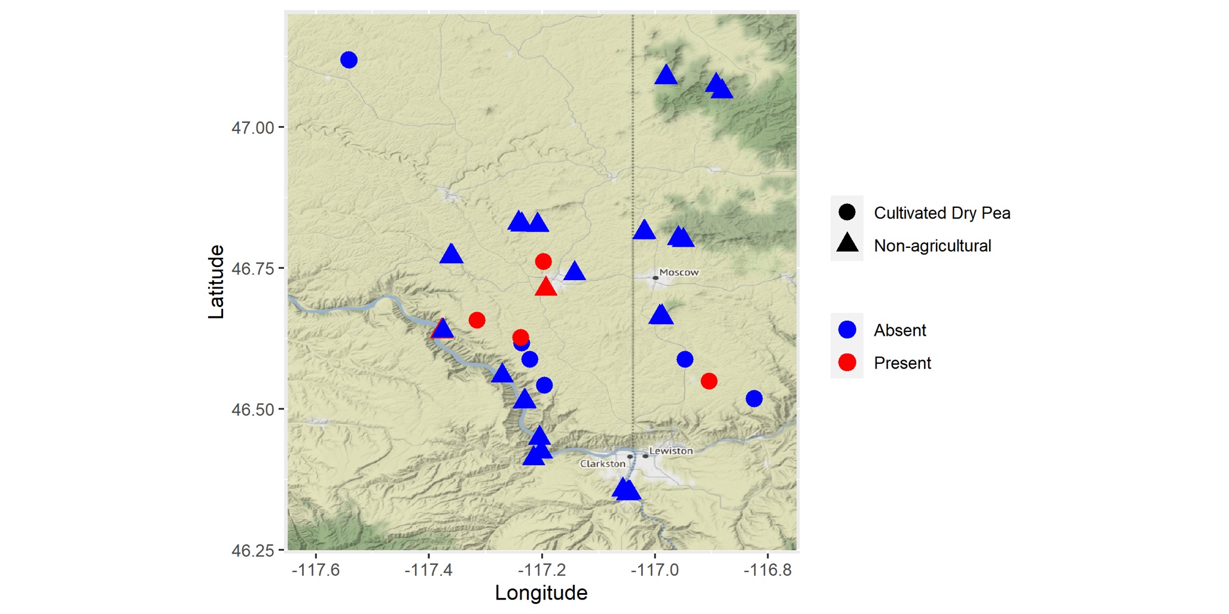

Fig. 2

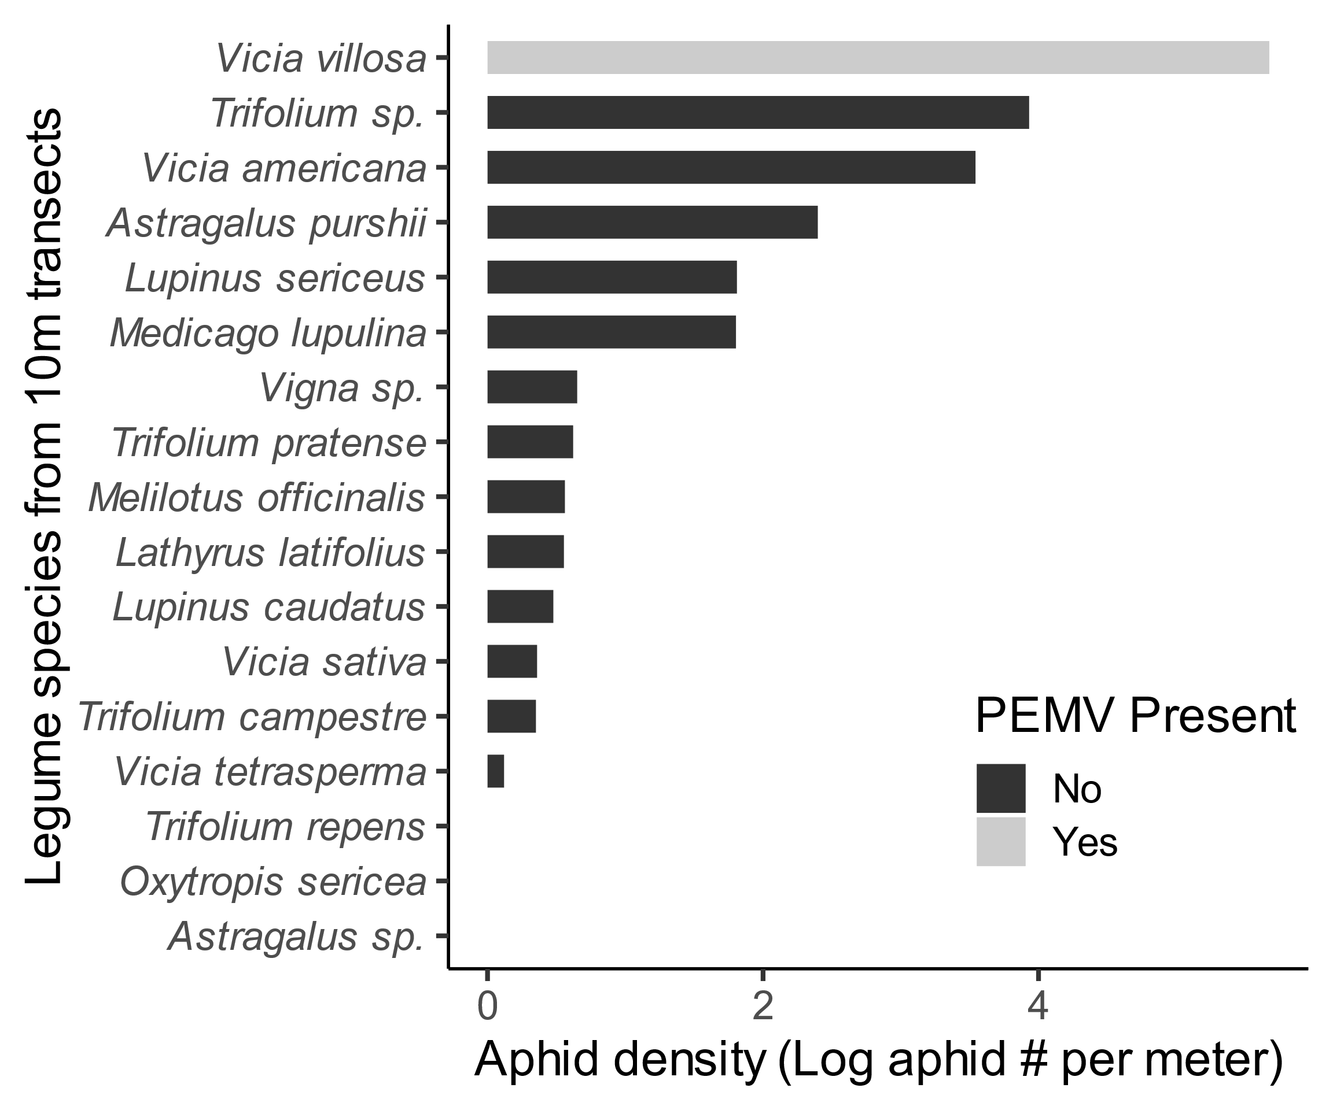

Fig. 3

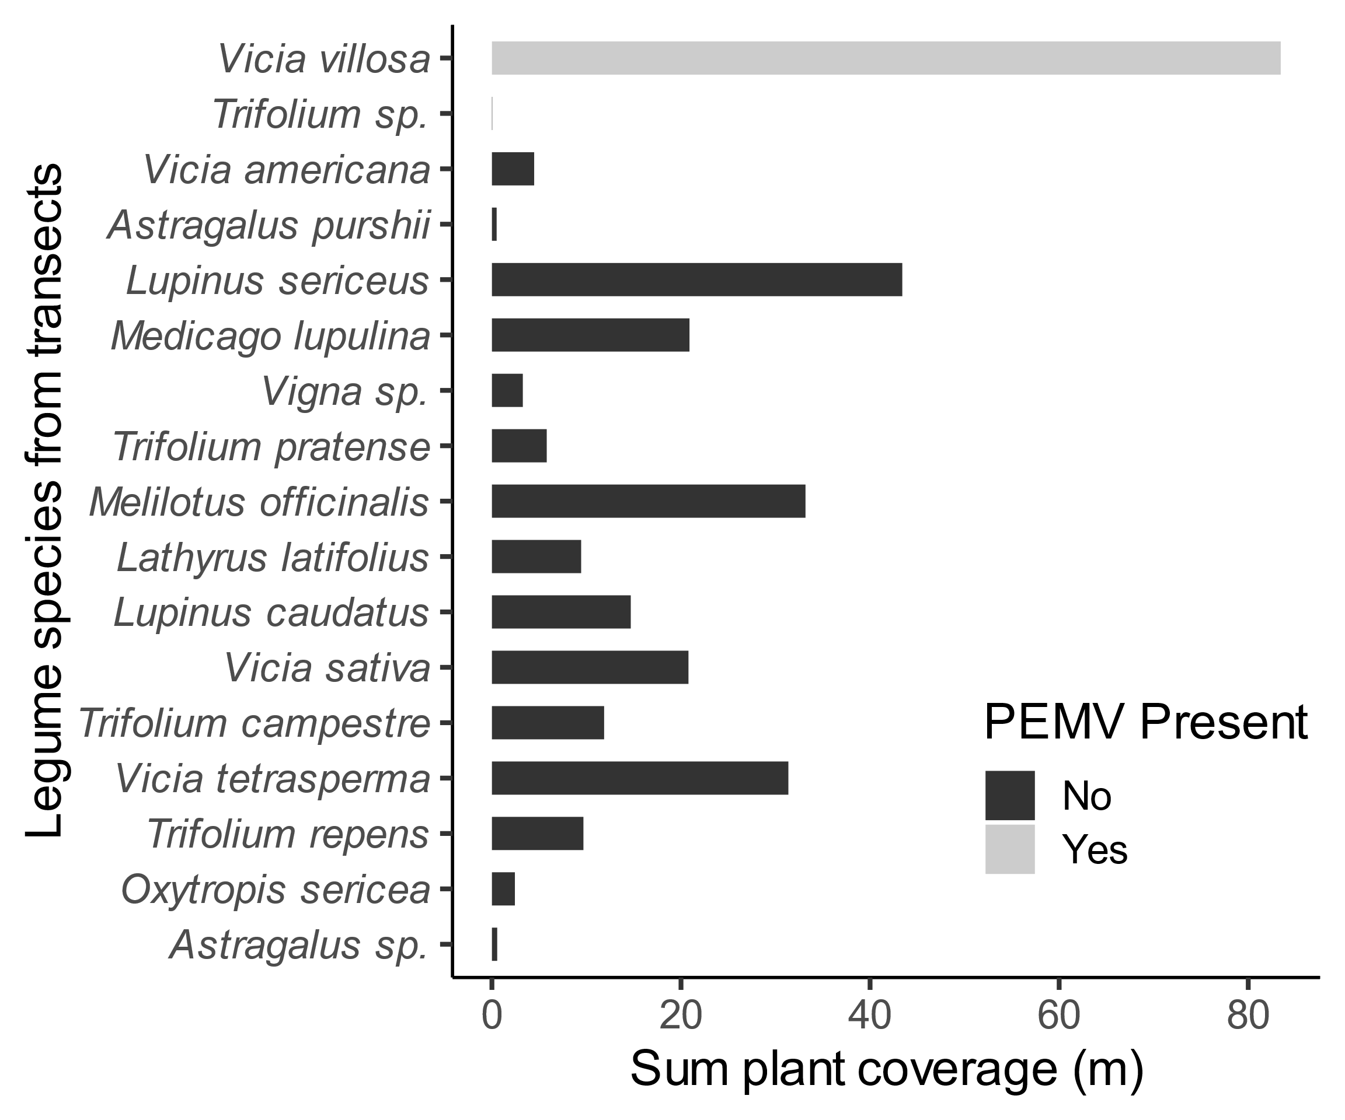

Fig. 4

